**High Performance Computing**

**Lab**

**Assignment No. 4**

**Name : Sourabh Shankar Patil**

**PRN : 21510045**

**Batch : B2**

**Title:** Study and Implementation of Synchronization

**Problem Statement 1: Fibonacci Computation using OpenMP with Synchronization**

# Analyse and implement a Parallel code for below programs using OpenMP considering synchronization requirements. (Demonstrate the use of different clauses and constructs wherever applicable)

# Fibonacci Computation:

**Screenshots:**

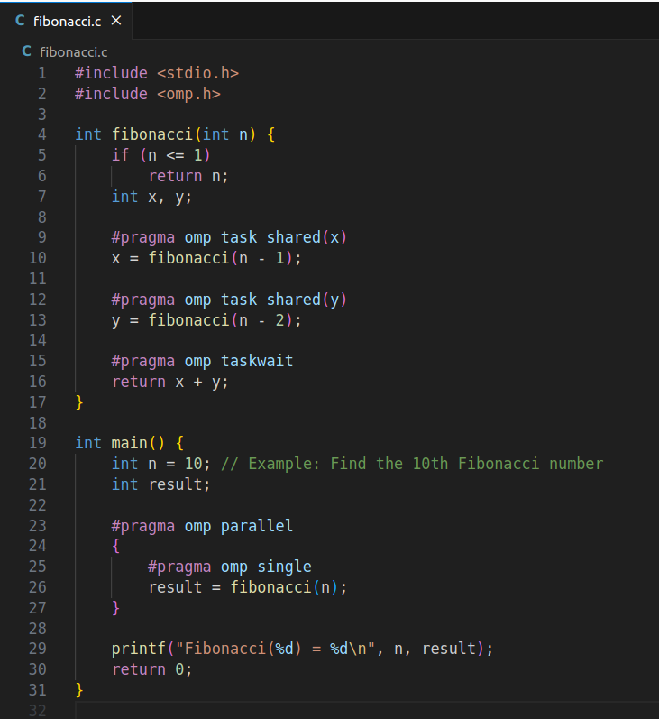

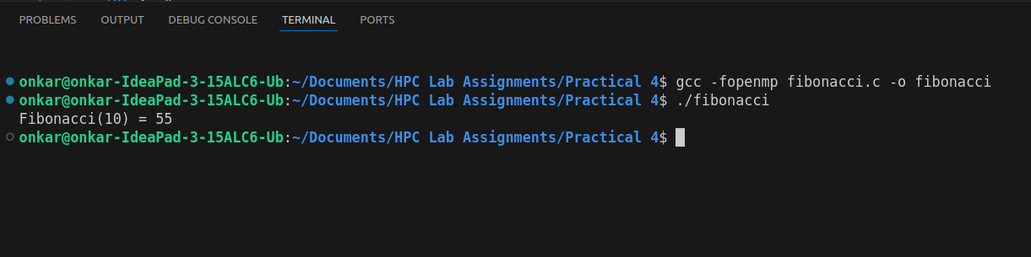

Information:

* The code uses #pragma omp task to parallelize the Fibonacci computation.
* The #pragma omp taskwait directive ensures synchronization between tasks.

**------------------------------------------------------------------------------------------------**

**Problem Statement 2: Producer-Consumer Problem using OpenMP with Synchronization**

# Analyse and implement a Parallel code for below programs using OpenMP considering synchronization requirements. (Demonstrate the use of different clauses and constructs wherever applicable)

## Producer Consumer Problem

**Screenshots:**

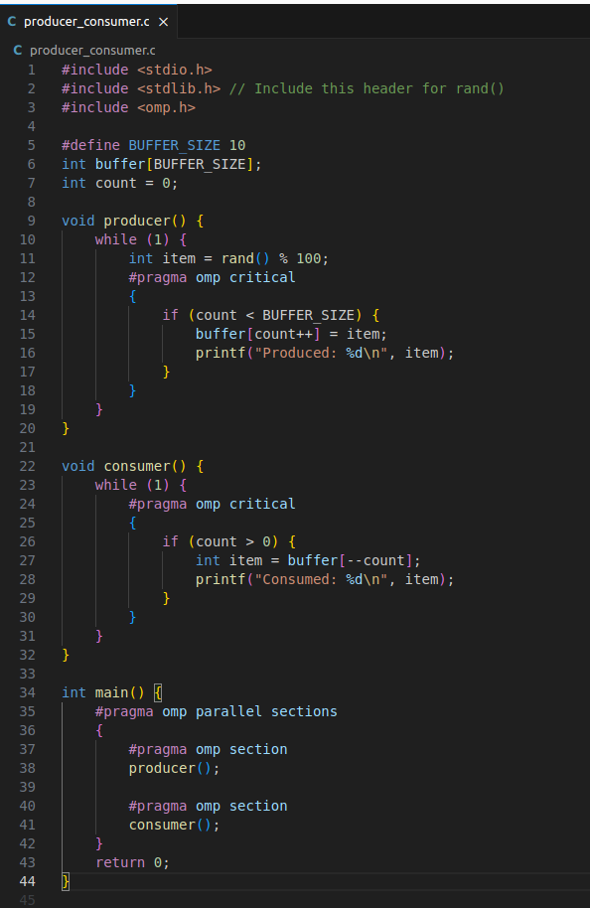

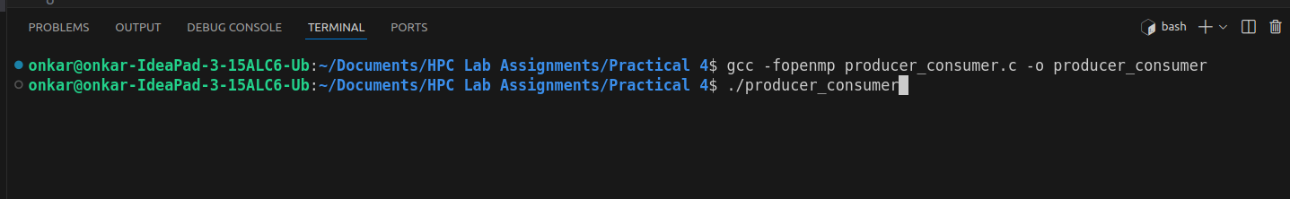

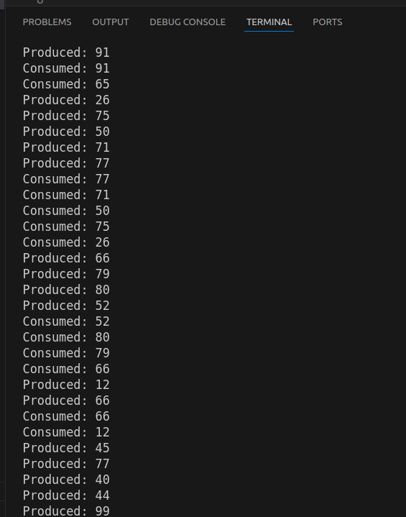

**Information:**

* The code uses #pragma omp sections to parallelize producer and consumer tasks.
* The #pragma omp critical directive ensures that only one thread modifies the buffer at a time, avoiding race conditions.

**Github Link:**

<https://github.com/sourabh-patil-7/HPC-Lab-Assignments/tree/main/Practical%204>